Technical Specification Form

PROJECT: PRODUCTION ORDER CONFIRMATION WITHOUT MPN

**Technical specification content**

1. Business Requirement
2. Development Tools
3. Development Objects

* Function Module
* DDIC Structure
* SEGW – OData Project.

1. Business API / OData API with Payload
2. Positive and Negative Testing Screenshot

SAP Technical Specification Form

|  |  |  |  |
| --- | --- | --- | --- |
| User Story ID # | 9000RUPESH | Module | PP |
| Date | 14-07-2025 | SL User |  |
| Consultant |  | Developer | Debidutta swain |
| Priority | ☐Urgent ☐High ☒Medium ☐Low | | |
| Application Type | ☐Report ☐Form ☐Interface ☒ODATA ☐Others | | |
| Execute Model | ☐Batch ☐ Foreground ☐Manual ☐Quarterly ☐Monthly  ☐Weekly ☐ Daily ☒Real time | | |
| Output Type | ☐Message ☐Dialog Screen ☐ABAP List ☒List View ☐ALV Grid | | |
| Remarks | Production order confirmation without MPN | | |

1. **Business Requirement:**

Develop an OData POST API for Production Order Confirmation Without MPN, through which Business user can Perform the Production Order Confirmation from Without MPN from External SAP application.

Through this API User can do Partial or Complete Order Confirmation though POST API call.  
  
Functional FS detail for Business Development :

**GET FOLLOWING DATA FROM CDS**

**ORDER NUMBER**

**POSTING DATE**

**CONFIRM QUANTITY**

**FINAL CONFIRMATION INDICATOR**

**RUN THE BAPI: BAPI_PRODORDCONF_CREATE_HDR**

**TABLES:**

**ORDERID = “404983411”**

**FIN_CONF = “X”**

**POSTG_DATE = “DATE FETCHED FROM CDS”**

**YIELD = “QUANTITY”**

**2.Development Tools :**

For development these are the following tool used :

* **OData Project**
* Created OData project with SEGW Tcode. Here I have used IMPORT from **DDIC structure** for Data modeling and Redefine the Creat Entity Method To Achieve our Business Requirement .
* For Service Registration used Tcode : /O/IWFND/MAINT_SERVICE.
* To Check the final data at Gateway Client used Tcode :/O/IWFND/GW_CLIENT.

**3.Development Objects :**

* **Function Module:**

BAPI Name: BAPI_PRODORDCONF_CREATE_HDR

Description : Enter Order Confirmations

* **DDIC Structure:**

Structure Name: ZPP_PRDC_CONF_WITHOUT_MPN_ST  
Description: Structure :Production Order Confirmation Without MPN

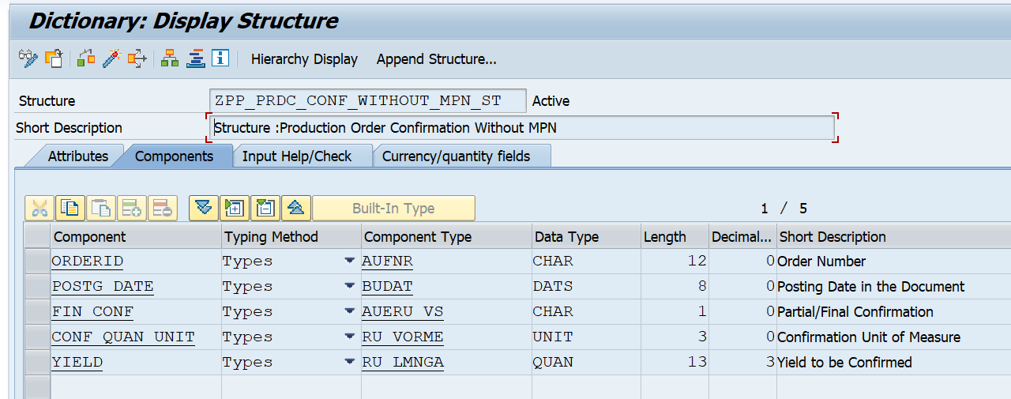

* **SEGW – OData Project:**

**Project Name:** ZGW_PP_PRDC_CONF_WITHOUT_MPN

**Service Name:** ZGW_PP_PRDC_CONF_WITHOUT_MPN_SRV

**Entity Type:** ProductionConf_woMPN

**Entity sets:** ProductionConf_woMPNSet

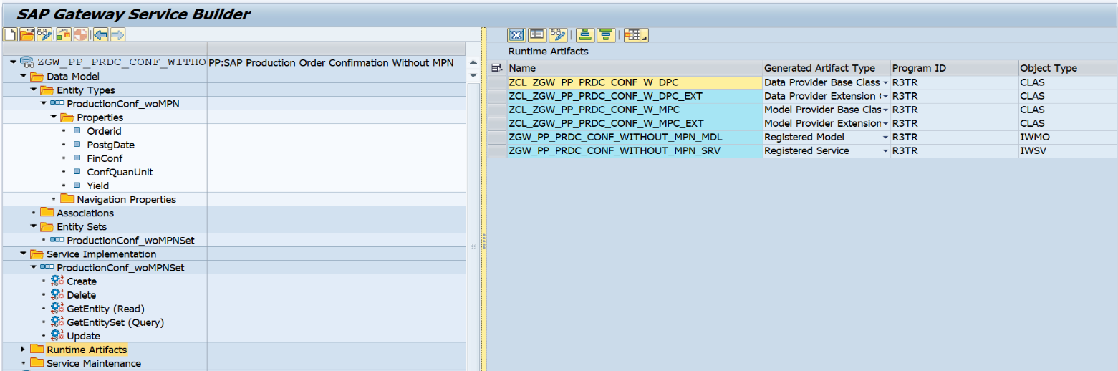

**Business Logic for Create Confirmation in SAP system:**

Class : ZCL_ZGW_PP_PRDC_CONF_W_DPC_EXT

Method: PRODUCTIONCONF_W_CREATE_ENTITY

Business Logic

method PRODUCTIONCONF_W_CREATE_ENTITY.*"--> Data Object Declaration.* DATA: LS_ENTITY      TYPE  ZCL_ZGW_PP_PRDC_CONF_W_MPC=>TS_PRODUCTIONCONF_WOMPN,  
         LS_ATHDRLEVELS TYPE  BAPI_PP_HDRLEVEL,  
         LT_ATHDRLEVELS TYPE TABLE OF BAPI_PP_HDRLEVEL,  
         LT_RETURN      TYPE TABLE OF BAPI_CORU_RETURN.  
  
   DATA: lo_message     TYPE REF TO /iwbep/if_message_container,  
         lt_return_msg  TYPE TABLE OF bapiret2,  
         lx_bus_ex      TYPE REF TO /iwbep/cx_mgw_busi_exception ##NEEDED.  
  
   IO_DATA_PROVIDER->READ_ENTRY_DATA(  
     importing  
       ES_DATA = LS_ENTITY  
   ).  
   IF LS_ENTITY IS NOT INITIAL.  
     LS_ATHDRLEVELS = CORRESPONDING #( LS_ENTITY ).  
     APPEND LS_ATHDRLEVELS TO LT_ATHDRLEVELS.*"--> Call Bapi for Business Operation.* CALL FUNCTION 'BAPI_PRODORDCONF_CREATE_HDR'  
       TABLES  
         ATHDRLEVELS                 = LT_ATHDRLEVELS  
         DETAIL_RETURN               = LT_RETURN.  
  
     lo_message = mo_context->get_message_container( ).  
     IF LT_RETURN IS NOT INITIAL.  
       READ TABLE LT_RETURN INTO DATA(LS_REURN_SUCCESS) WITH KEY TYPE = 'I' ID = 'RU' NUMBER = '100'.  
       IF SY-SUBRC EQ 0.  
         LO_MESSAGE->ADD_MESSAGE(  
           exporting  
             IV_MSG_TYPE               =   /iwbep/cl_cos_logger=>SUCCESS*" Message Type* IV_MSG_ID                 =   LS_REURN_SUCCESS-ID*" Message Class* IV_MSG_NUMBER             =   LS_REURN_SUCCESS-NUMBER*" Message Number* IV_MSG_TEXT               =   LS_REURN_SUCCESS-MESSAGE*" MESSAGE TEXT* IV_ADD_TO_RESPONSE_HEADER =   ABAP_TRUE*"add the message to the header* ).  
       ELSE.  
         LT_RETURN_MSG = CORRESPONDING #( LT_RETURN ).  
         lo_message->add_messages_from_bapi(  
          EXPORTING  
           it_bapi_messages          = LT_RETURN_MSG  
           ).  
         RAISE EXCEPTION TYPE /iwbep/cx_mgw_busi_exception  
         EXPORTING  
          textid            = /iwbep/cx_mgw_busi_exception=>BUSINESS_ERROR  
          message_container = lo_message.  
       ENDIF.  
  
     ENDIF.  
   ENDIF.  
  endmethod.

**4.Business API / OData API with Payload :**

Post API : /sap/opu/odata/sap/ZGW_PP_PRDC_CONF_WITHOUT_MPN_SRV/ProductionConf_woMPNSet

{  
    "Orderid" : "404983422",  
    "PostgDate" : "\/Date(1752192000000)\/",  
    "FinConf" : "X",  
    "Yield" : "94.000"  
}

Payload:

**5.Positive and Negative Testing Screenshot**

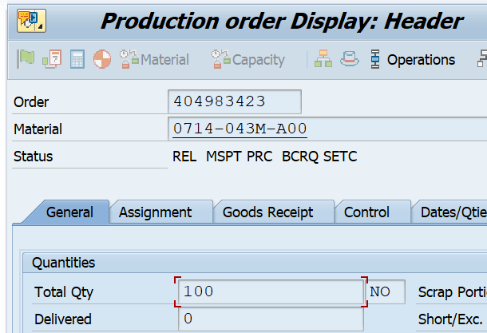**Positive Testing :**for transferring one quantity of a existing Order Number “404983423”.here before Perform the order confirmation of 1 Quantity Request ,the delivered Quantity is ‘0’.

But after Send a request of “Production Order Confirmation Without MPN” Quantity of “1” The delivered quantity turns from 0 to 1.

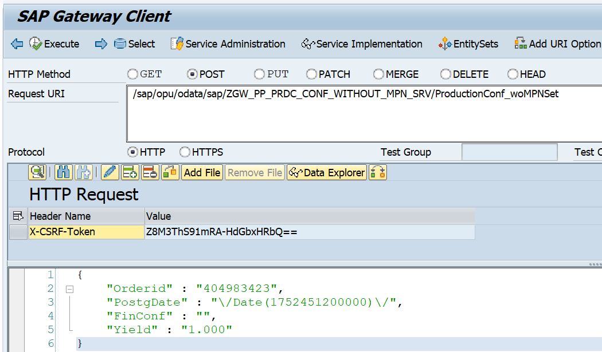Request Sanded Screenshot:

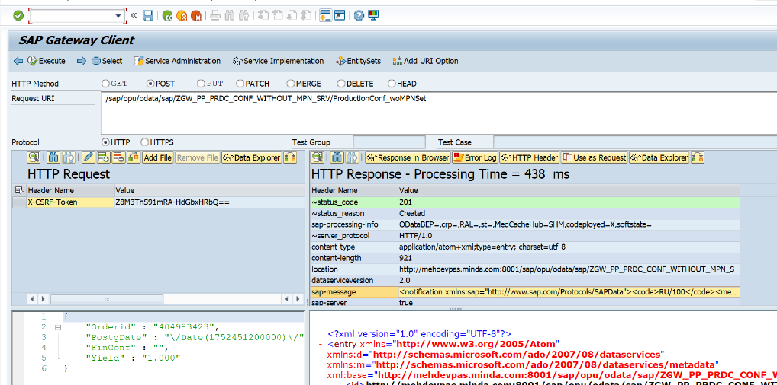Positive Response from Backend :

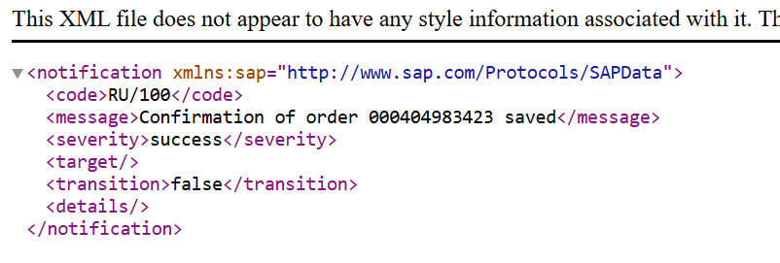Success Message shown in Header Sections’s “sap-message” Tab:

Success Message : RU/100: Confirmation of order 000404983423 saved

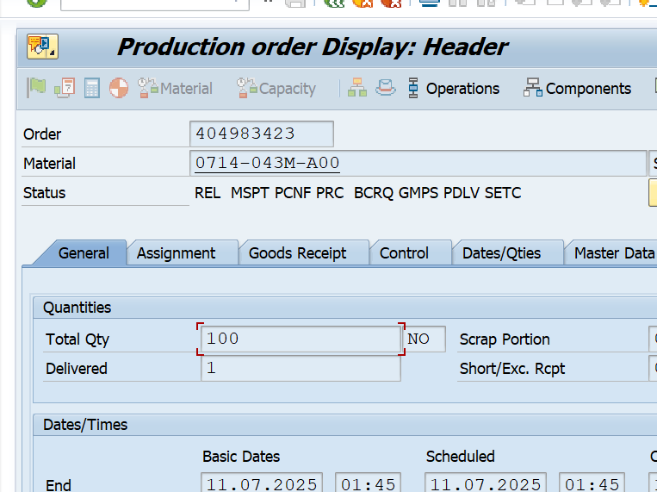Backend Level Varification :

**Negative Testing:**

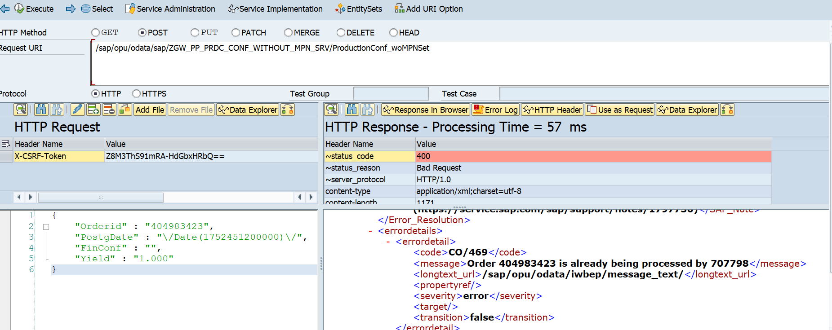**Case 1:** if I want to do a Production Confirmation on existing Order Number, but at the same time some other user trying to change/perform PO Confirmation on the same Order Number, Then the following Error message will come from Backend as Response -Body.

Error : CO/469 (Order 404983423 is already being processed by <UserID>).

**Case 2:** If user try to Deliver over Quantity in a PO confirmation Request, The following Error came from Backend as Response in Response Body.  
  
Ex :

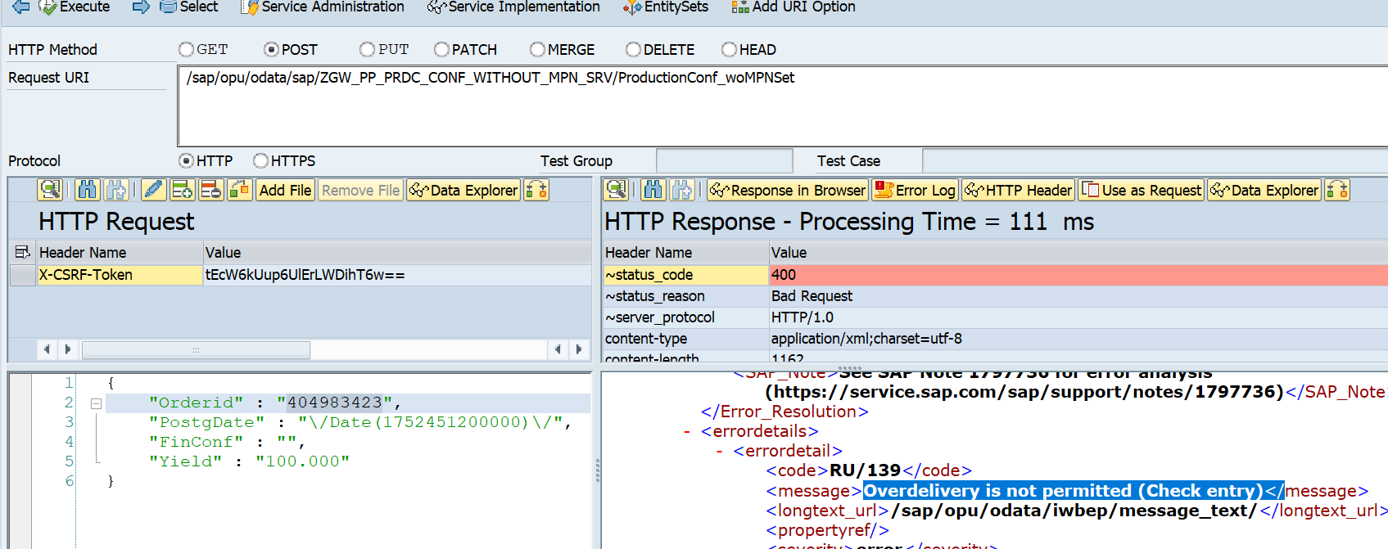in the order Number : 404983423, already I have delivered 2 quantity out of 100 quantity and remaining 98 quantity are remaining, but I am trying to deliver 100 quantity, then system will send error message from backend as a response to Front end.  
  
Error : RU/139 : Overdelivery is not permitted (Check entry)

**Case 3:** IF I am trying to do the final confirmation without delivering the total planned Quantity, then System will through the following Error.  
  
Ex:

in the order Number : 404983423, already I have delivered 32 quantity out of 100 quantity and remaining 68 quantity are remaining, but I am trying perform the final Confirmation without Giving the complete remaining quantity or less the remaining Quantity, then system will give error message as response to the frontend in Response Body.

Error : RU/117 : Total quantity confirmed not equal to planned quantity to be confirmed.

System Screenshot :

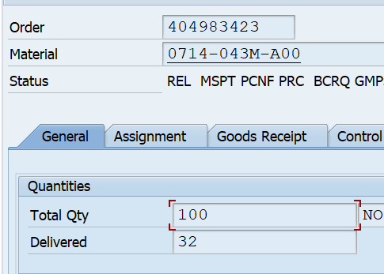co03

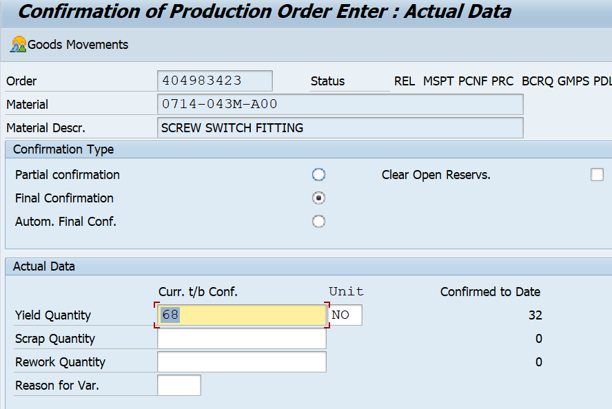

Co15

Gateway screenshot with Response:

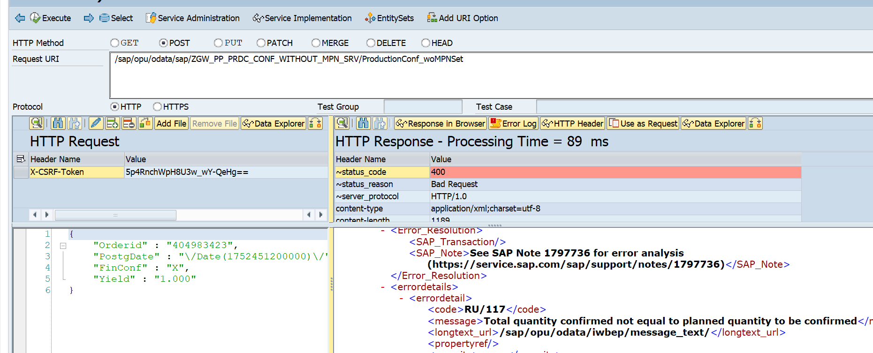Here I am Trying to do the final confirmation by passing only 1 quantity where the remaining delivery quantity is 68.

**Case 4:** If I am trying to do a confirmation of a Order, which don’t have any Existance.

Error : RU/002 : Order 40498342 not found, check entry.

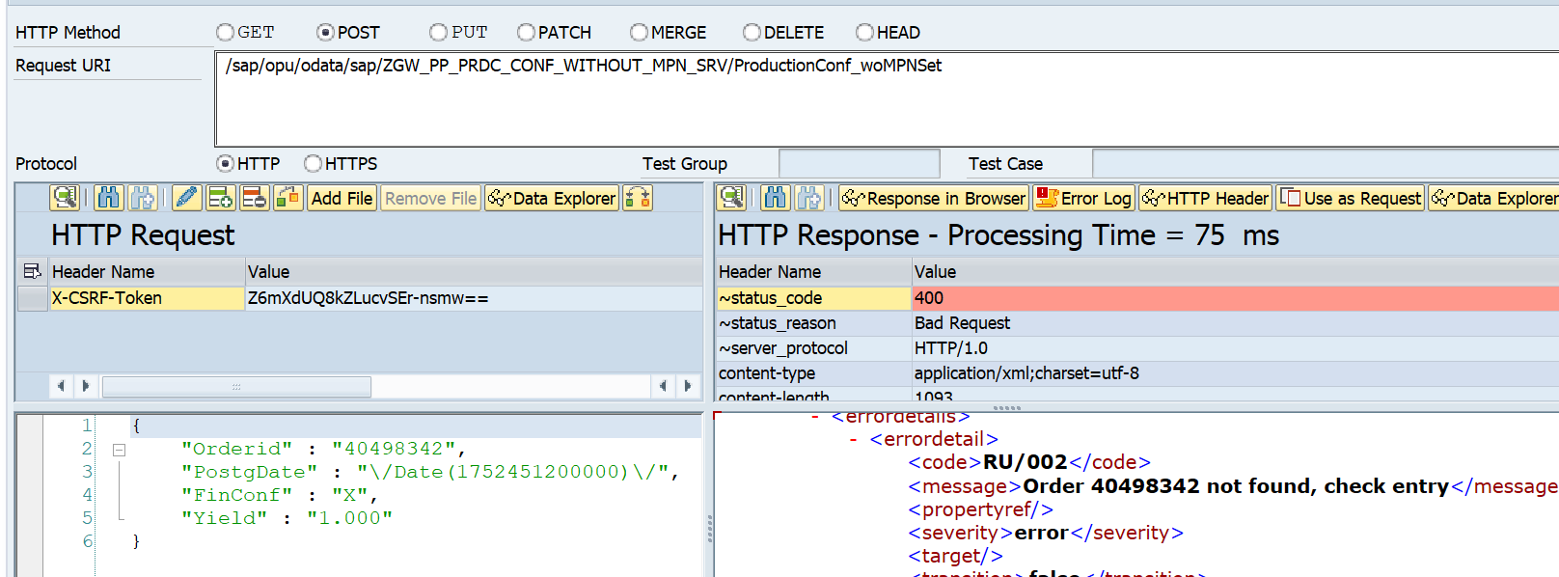

Case 5: if I am trying to do a order confirmation whose, final confirmation already done.  
  
System screenshot for final confirmation:  
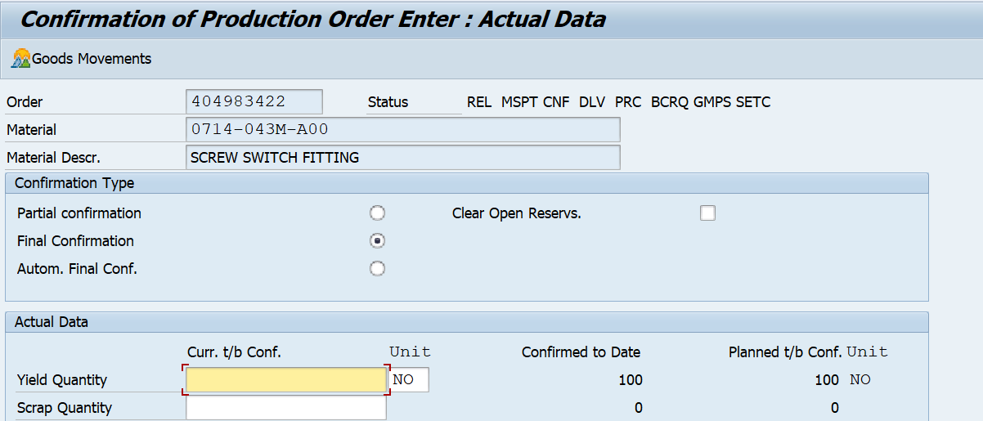

For this above scenario , if a user try to send a request for order confirmation then following Error message will send by system as a Response in Response Body.

Error : RU/139 : Overdelivery is not permitted (Check entry).  
